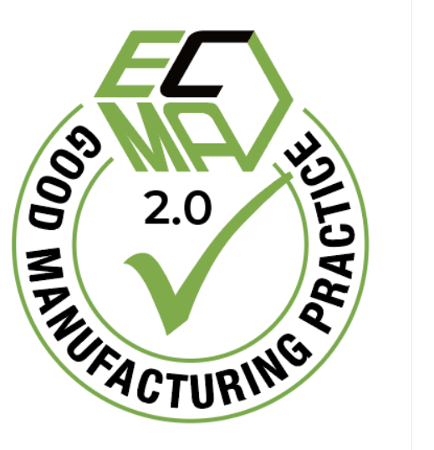

Company Logo

Self-declaration & commitments

related to the manufacture and supply of carton food packaging

Company name, being a member of ECMA, has committed to the following principles in order to insure the observance of food consumer safety within the areas under its control.

These commitments, to be applied by each company in the way it decides appropriate, cover all food cartons manufactured at the following quality and hygiene certified plant:

Name and address : ………………………………………………………………………………………

Obtained GFSI certification BRCGS Packaging Materials Issue 6
FSSC 22000
IFS Packsecure
Rating : ……………………………….
Valid until : ……………………………

This self-declared compliance gives our company the right to use the ECMA GMP compliance seal for the indicated plants, and to be listed on the ECMA website. (*)

We are committed to:

- the principle of placing consumer safety first;
- compliance with relevant food safety legislation currently in force and the resultant legal requirements, through the introduction of best practices and the best available technology;
- the principles of transparency and information sharing to enable compliance within the packaging supply chain, whilst preserving appropriate commercial confidentiality and respecting competition law rules;
- the supply of food cartons fit for the intended purpose as mutually defined between each company and its customers;
- the concept of risk assessment in accordance with internationally recognized scientific principles;
- the principles and implementation of the carton manufacturing specific ECMA Good Manufacturing Practices,
- allow assessments on the GMP implementation by a third party;
- the principle of continuous improvement in consumer safety in the light of any new scientific findings;
- follow ECMA’s ongoing guidance and food safety recommendations.

Company: Date: Signature:
____________________________________________________________________________

(*) Disclaimer : As this ECMA developed GMP compliance seal is self declared and voluntary, it may not be construed by any means as an approval or endorsement by ECMA of compliance with the GMP guide or with any applicable requirements, including the safety requirement, of cartons manufactured by companies using the seal.
The publication by ECMA of the list of self-declared compliant companies using the seal is not either to be construed as an approval or endorsement by ECMA. The use of the seal is made by each individual company under its sole responsibility, having due regard
to the GMP guide and the applicable legislation.

